**Week 4 – LAB2**

1. **First question: Lucky number**

Write a program that print your lucky number. Name your class LuckyNumber. The output must be as the following:

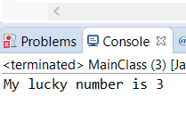

1. **Second question: print information**

Write a Java program that prints the following:

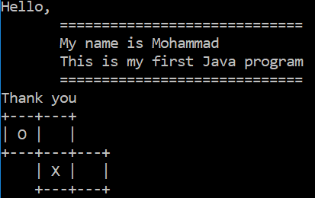

**Note 1:** Change the output so it prints your name in the third line.

**Note 2:** use \n and \t

1. **Third question: multiplication table**

Write a Java program that prints the multiplication table of 9 as the following:

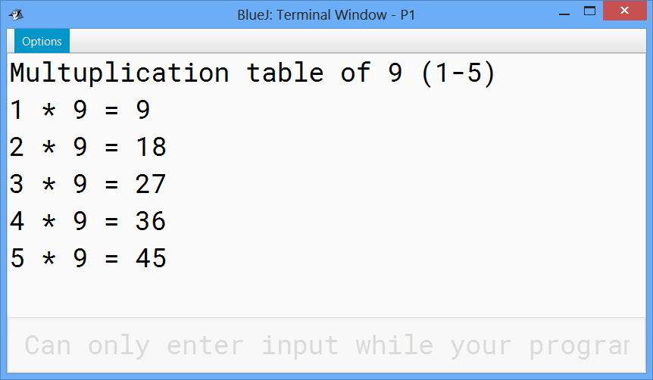

1. **Fourth question: Hello program!!!**

Scanner class in java library is used to read keyboard input.

Write a program that do the following:

* Ask the user to enter his/her full name.
* Read the input and store it in the variable (name)
* Print a welcome message with the user name.

1. **Fifth question: Seconds converter**

Write java program that allow the user to enter:

* The number of seconds
* The number of minutes
* The number of hours

Print the corresponding total number of seconds

**Typical run of the program**

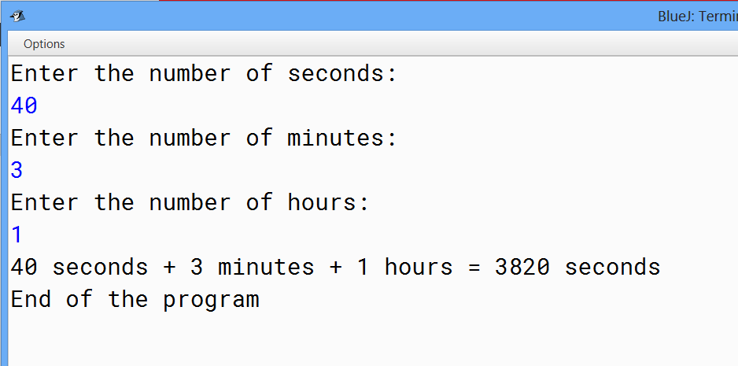

1. **Sixth question: SAR bills calculator**

Create java program that ask the user to enter an amount in Saudi Riyal.

The program must print the minimum number of bills required to get the given amount.

The program should also print the number within each kind of bill.

***Typical run of the program:***

***Scenario 1:***

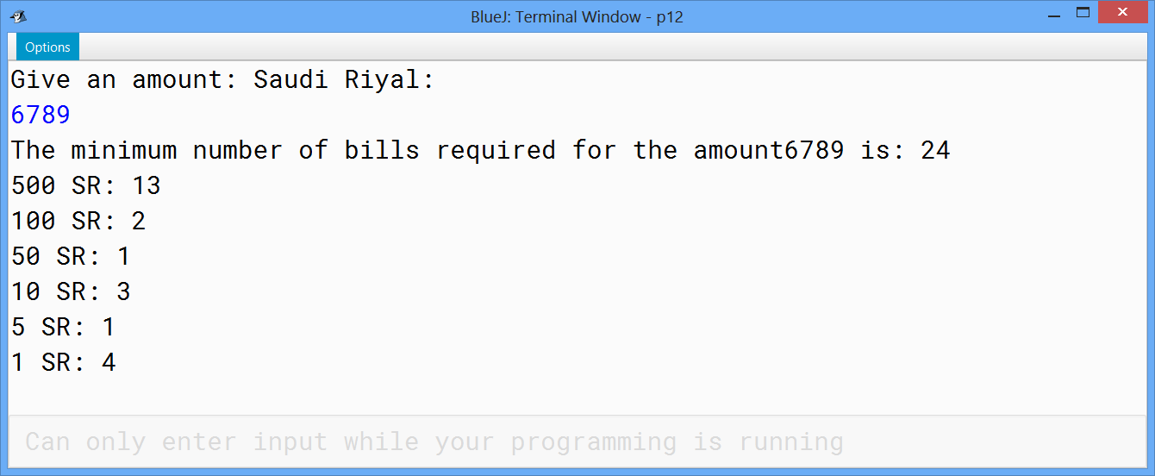

***Scenario 2:***

